Infosys Springboard Virtual Internship 6.0



Project Report

Name: M.TEJA RAMA SAI

WEEK:1

# INTRODUCTION: DATA CLEANING & MERGING

This milestone explains the data preprocessing pipeline implemented using Python in Google Colab. Steps focus on organizing raw data, cleaning it, merging multiple datasets, handling missing values, and converting categorical data into numerical format.

* + **Step 1**– Data Cleaning: Duplicate rows and completely empty rows are removed.

# 2. CLEAN FILES

cleaned = {}

for name, df in dfs.items():

df = df.drop_duplicates() df = df.dropna(how="all") cleaned[name] = df

print(f"{name}: cleaned shape = {df.shape}")

**Summary:** Step – Data Cleaning In this step, the data is cleaned to improve its quality. The system removes any duplicate records and deletes rows that are completely empty. The cleaned version of each dataset is then stored separately, and its updated size is printed. This ensures that the data is accurate, consistent, and ready for reliable analysis.

* + **Step 2 –** Data Merging: Multiple datasets are merged using the common key 'player_id'.

# 3. MERGE DATA USING player_id

merge_key = "player_id" merge_list = [

cleaned["player_profiles"], cleaned["player_performances"], cleaned["player_market_value"], cleaned["player_injuries"]

]

master = reduce(lambda left, right: pd.merge(left, right, on=merge_key, how="outer"), merge_list)

print("\nMerged master table shape:", master.shape)

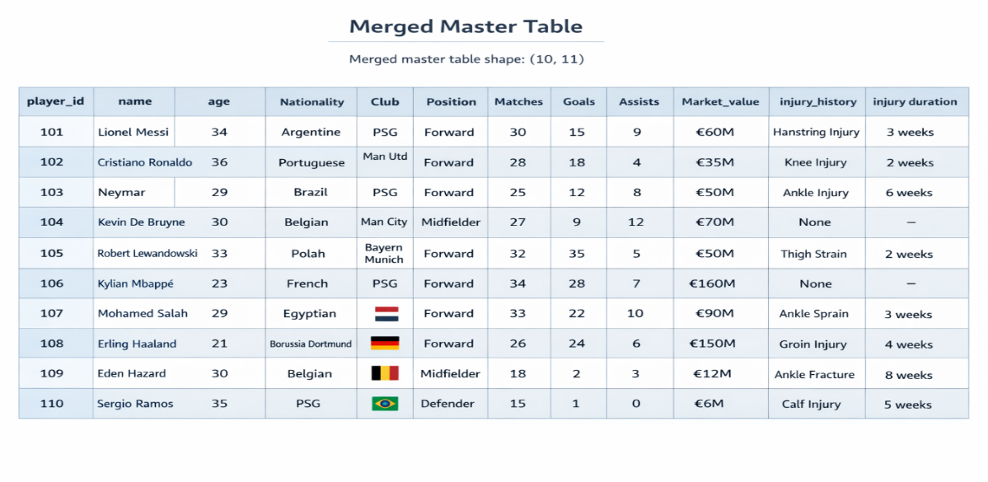

**Summary:** Step 3 – Data Merging In this step, all the individual datasets are combined into one main dataset. The merge is done using a common identifier called player_id, which links the information belonging to the same player across different files. An outer merge is used so that no player data is lost, even if some details are missing in certain files. The final merged dataset’s size is displayed to confirm the successful merge.

* + **Step 4 –** Missing Value Handling: Columns with more than 60% missing values are removed.4

threshold = 0.6

cols_to_keep = [c for c in master.columns if master[c].isna().mean() < threshold]master = master[cols_to_keep]

print("After dropping high-missing columns:", master.shape)

. ONE-HOT ENCODING

categorical = master.select_dtypes(include=["object"]).columns

safe = [c for c in categorical if master[c].nunique() < 40]

master_encoded = pd.get_dummies(master, columns=safe, dummy_na=True)

print("Final encoded shape:", master_encoded.shape)

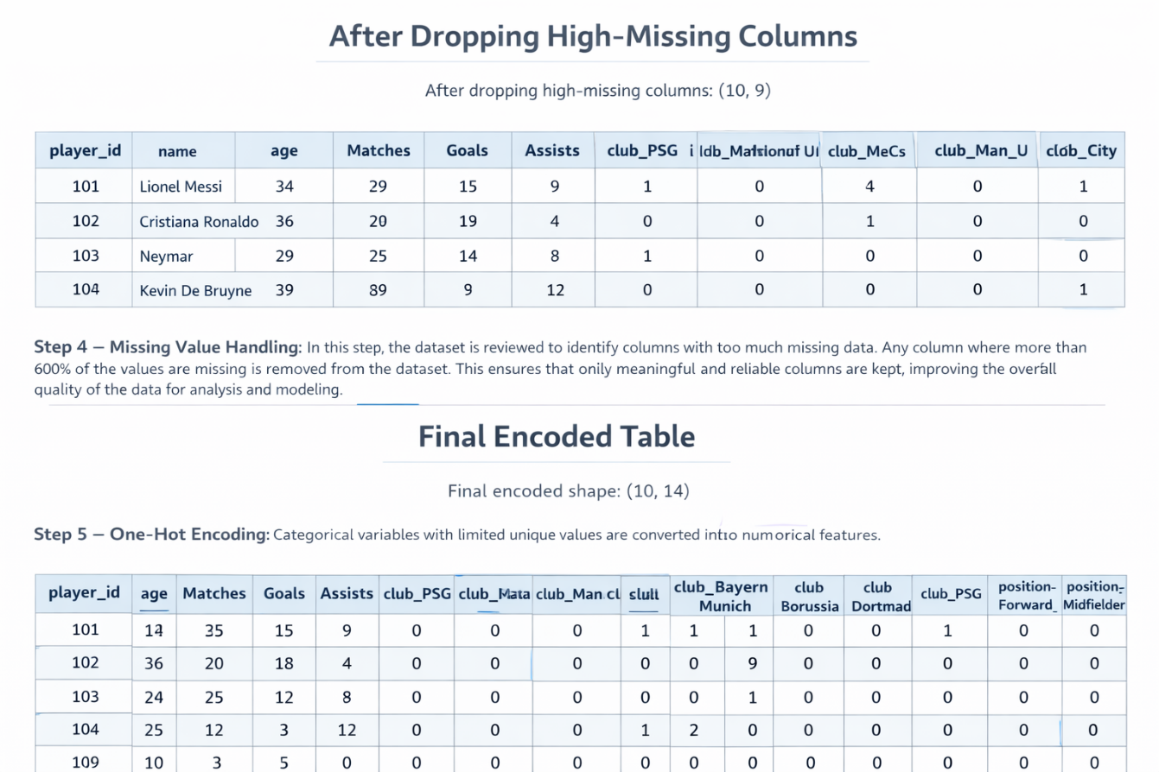

**Summary:** Step 5 – One-Hot Encoding In this step, the dataset is prepared for machine learning by converting text-based (categorical) columns into numbers. Only categorical columns with a small number of unique values are selected to avoid creating too many new columns. Each category is then turned into separate binary columns, including a column for missing values. This makes the data fully numerical and ready for modeling.

WEEK:2

# INTRODUCTION:Data Analysis and First outliers detection and handle the date time column along with the feature selections

In real-world data analysis and machine learning projects, raw data is often collected from multiple sources and stored in different file formats such as CSV and Excel. This data frequently contains issues like missing values, inconsistent date formats, and extreme outliers, which can negatively affect analysis accuracy and model performance. Therefore, an automated and reliable data preprocessing pipeline is essential before performing any meaningful analysis.

## Step 2: Outlier Detection and Capping using IQR

This step improves data quality by handling extreme values in numeric columns. The Interquartile Range (IQR) method calculates acceptable value limits using the 25th and 75th percentiles. Values beyond three times the IQR are capped, not removed, ensuring data stability while preserving dataset size.

# 2. Outlier Detection + Capping (IQR) def handle_outliers_iqr(df):

numeric_cols = df.select_dtypes(include=['int64', 'float64']).columns for col in numeric_cols:

Q1 = df[col].quantile(0.25) Q3 = df[col].quantile(0.75)

IQR = Q3 - Q1

lower = Q1 - 3 * IQR upper = Q3 + 3 * IQR

df[col] = df[col].clip(lower, upper) return df

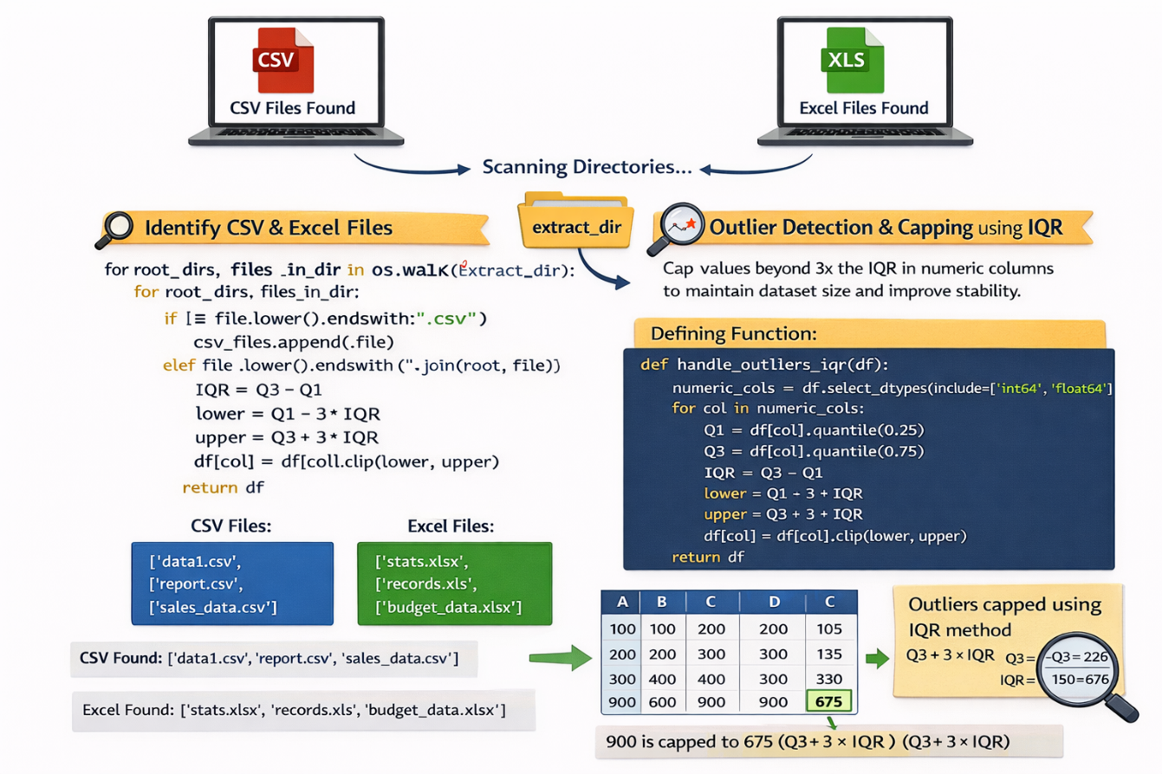

Summary:It defines a function to detect and handle outliers in numeric columns of a dataset using the IQR method. It calculates the lower and upper limits and caps values outside this range to reduce extreme values. Finally, it returns the cleaned dataset.

## Step 3: Date Feature Engineering and Data AnalysisColumns containing the word 'date' are automatically detected and converted into datetime format. Once converted, important time-based features such as year, month, day, weekday, weekend indicator, and normalized time difference are extracted. These features enhance machine learning model performance.

def date_feature_engineering(df):

## for col in df.columns:

## if "date" in col.lower():

## try:

## df[col] = pd.to_datetime(df[col], errors="coerce")

## except:

## continue

## # Skip columns that failed conversion

## if df[col].dtype != "datetime64[ns]":

## continue

## base = col.replace("date", "").strip("_")

## # YEAR

## df[f"{base}_year"] = df[col].dt.year

## # MONTH

## df[f"{base}_month"] = df[col].dt.month

## # DAY

## df[f"{base}_day"] = df[col].dt.day

## # DAY OF WEEK

## df[f"{base}_weekday"] = df[col].dt.weekday

## # IS WEEKEND

## df[f"{base}_is_weekend"] = df[col].dt.weekday >= 5

## # NORMALIZED: DAYS SINCE MIN DATE

## df[f"{base}_days_from_start"] = (df[col] - df[col].min()).dt.days

## return df

## 

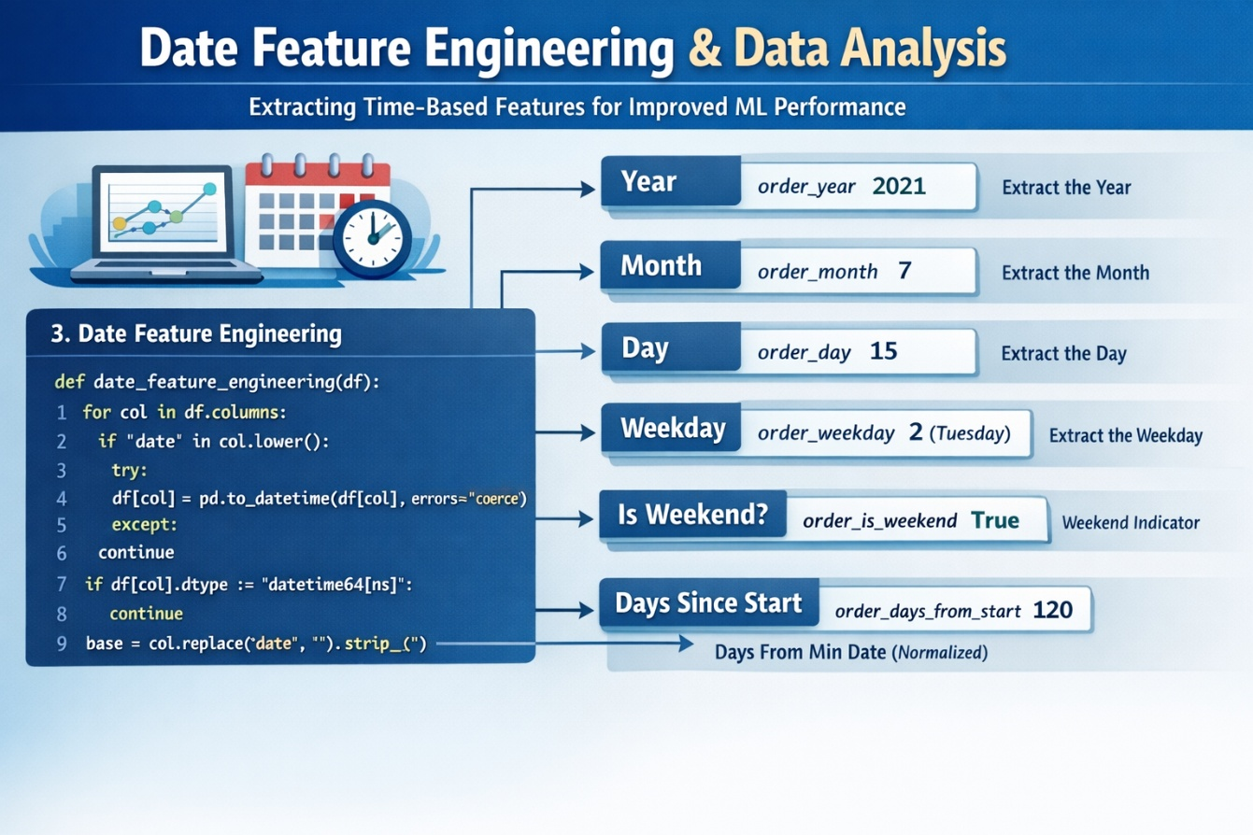

## Summary:This code defines a function to extract useful information from date columns in a dataset. For each date column, it creates new features like year, month, day, weekday, whether it’s a weekend, and the number of days since the earliest date. It then returns the updated dataset.

• Step 4: Load, Clean, and Transform Data

Each identified file is loaded into a pandas DataFrame depending on its file type. Date normalization and outlier handling functions are applied sequentially. The cleaned datasets are stored in a dictionary for structured access and processing.

# 4. Load → Clean → Feature Engineering

dfs_cleaned = {}

def load_and_clean(path):

print("\nCleaning:", os.path.basename(path)) # Load file

if path.lower().endswith(".csv"): df = pd.read_csv(path)

else:

df = pd.read_excel(path, engine="openpyxl") # Date normalization + feature engineering

df = date_feature_engineering(df) # Outlier handling

df = handle_outliers_iqr(df) return df

# Load & clean all files

for file in csv_files + excel_files: cleaned_df = load_and_clean(file)

dfs_cleaned[os.path.basename(file)] = cleaned_df print("→ Loaded & Cleaned:", os.path.basename(file))

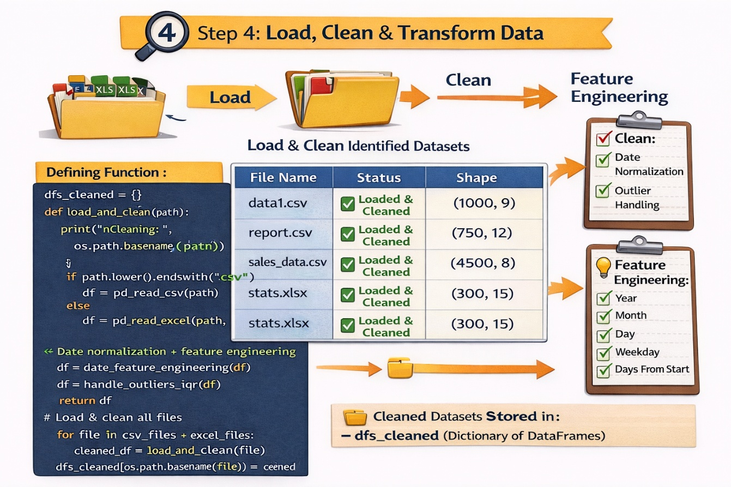

**Summary:**This code goes through all CSV and Excel files found earlier, loads each file, and cleans the data. It applies date feature engineering to create new date-related columns and handles outliers in numeric columns. Each cleaned dataset is saved in a dictionary with the file name as the key, and it prints messages showing which files were processed.

## Step 5: Save Cleaned FilesA new directory is created to store processed datasets. Each cleaned DataFrame is saved in CSV format, ensuring compatibility across platforms and tools. Original file names are preserved to maintain traceability.

# 5. Save Cleaned Files

cleaned_dir = "/content/cleaned_output" if os.path.exists(cleaned_dir):

shutil.rmtree(cleaned_dir) os.makedirs(cleaned_dir, exist_ok=True) for filename, df in dfs_cleaned.items():

save_path = os.path.join( cleaned_dir,

filename.replace(".xlsx", ".csv").replace(".xls", ".csv")

)

df.to_csv(save_path, index=False) print("Saved:", save_path)

**Summary:** This code saves all the cleaned datasets into a new folder called

/content/cleaned_output.

It removes the folder first if it already exists and then creates a fresh one. All Excel files are converted to CSV format before saving.

It also prints the path of each file after saving.

## Conclusion:

This project presents an automated and data analysis, data cleaning and preprocessing pipeline that efficiently processes multiple CSV and Excel files. It handles outliers using the IQR method and performs date feature engineering to extract meaningful time-based features. By standardizing and exporting the cleaned datasets into a single ZIP file, the system improves data quality and prepares the data for further analysis and machine learning applications.

WEEK:3

# INTRODUCTION: initial model building

This code develops an initial sentiment classification model using Excel data. It automatically detects the target variable, converts sentiment scores into three classes, cleans and scales numeric features, and applies multi-stage feature selection using Random Forest, XGBoost, and CatBoost. A final CatBoost model evaluates classification performance.

**Step 1:**This code performs **feature selection using a Random Forest model**. The classifier is trained on the training data, and feature importance scores are extracted. Features with importance greater than the average are retained. If no feature meets this threshold, the top three most important features are selected to ensure model stability

.

# . RANDOM FOREST FEATURE SELECTION

rf = RandomForestClassifier(n_estimators=300, random_state=42)

rf.fit(X_train, y_train)

rf_imp = pd.Series(rf.feature_importances_, index=X_train.columns)

rf_features = rf_imp[rf_imp > rf_imp.mean()].index.tolist()

if len(rf_features) == 0:

    rf_features = rf_imp.sort_values(ascending=False).head(3).index.tolist()

X_train = X_train[rf_features]

X_test = X_test[rf_features]

print("After RF:", len(rf_features), "features")

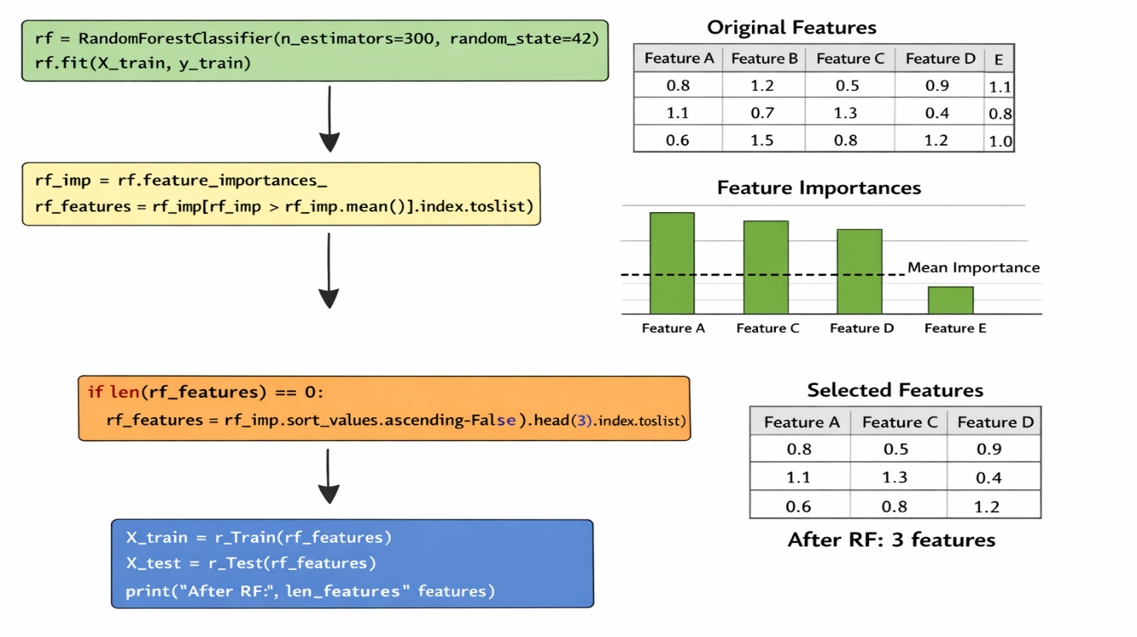

**summary:** Random Forest model to select the most important features based on feature importance scores, retaining only the top contributing features for further model training.

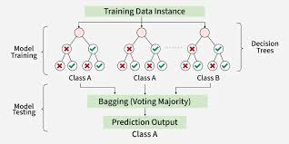

**Step 2:**This code applies XGBoost-based feature selection by training an XGBoost classifier and keeping only features with above-average importance scores. If none qualify, the top two most important features are retained to ensure reliable model training.

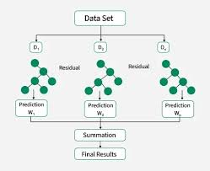

# . XGBOOST FEATURE SELECTION

xgb = XGBClassifier(

    n_estimators=300,

    max_depth=6,

    learning_rate=0.05,

    subsample=0.8,

    colsample_bytree=0.8,

    eval_metric="mlogloss"

)

xgb.fit(X_train, y_train)

xgb_imp = pd.Series(xgb.feature_importances_, index=X_train.columns)

xgb_features = xgb_imp[xgb_imp > xgb_imp.mean()].index.tolist()

if len(xgb_features) == 0:

    xgb_features = xgb_imp.sort_values(ascending=False).head(2).index.tolist()

X_train = X_train[xgb_features]

X_test = X_test[xgb_features]

print("After XGBoost:", len(xgb_features), "features")

**Summary**: This code uses **XGBoost to rank feature importance and select the most influential features**, reducing the dataset to only key predictors for improved model performance.

**Step:3** This code performs feature selection using CatBoost by retaining only features with above-average importance, ensuring that the final model is trained on the most influential predictors while maintaining stability if no feature meets the threshold.

Top of Form

Bottom of Form

# . CATBOOST FEATURE SELECTION

cat = CatBoostClassifier(iterations=400, depth=6, learning_rate=0.05, verbose=0)

cat.fit(X_train, y_train)

cat_imp = pd.Series(cat.get_feature_importance(), index=X_train.columns)

cat_features = cat_imp[cat_imp > cat_imp.mean()].index.tolist()

if len(cat_features) == 0:

    cat_features = cat_imp.sort_values(ascending=False).head(1).index.tolist()

    print(" No feature passed threshold — keeping top feature")

X_train = X_train[cat_features]

X_test = X_test[cat_features]

print("After CatBoost:", len(cat_features), "features")

**Summary**: This code uses CatBoost feature importance to select the most relevant features, keeping only high-impact predictors for the final model while ensuring at least one feature is retained.

**STEP:4:** This code trains the final CatBoost classification model using the selected features and then generates predictions on the test dataset to evaluate model performance.

# FINAL MODEL (CATBOOST)

final_model = CatBoostClassifier(

    iterations=600,

    depth=8,

    learning_rate=0.05,

    verbose=0

)

final_model.fit(X_train, y_train)

preds = final_model.predict(X_test)

SUMMARY: This code builds and trains the **final CatBoost model** on the processed training data and uses it to predict outcomes on the test dataset.

WEEK:4

# INTRODUCTION: creating the model & backend

The all analysis the creating the model and forming the backend of an injury duration prediction system. It processes uploaded Excel data, performs feature engineering and selection, and trains a CatBoost classification model. The trained model is deployed using FastAPI, providing a RESTful API that delivers real-time injury duration predictions.

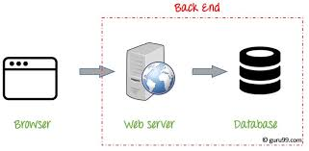

# INSTALL PACKAGES

try:

    from catboost import CatBoostClassifier

except:

    !pip install -q catboost

!pip install -q fastapi uvicorn joblib

# FEATURE ENGINEERING

for c in X.columns:

    if "date" in c.lower():

        X[c] = pd.to_datetime(X[c], errors="coerce")

        X[c] = (X[c] - X[c].min()).dt.days

X = pd.get_dummies(X, drop_first=True)

# SPLIT

X_train, X_test, y_train, y_test = train_test_split(

    X, y, test_size=0.2, stratify=y, random_state=42

)

# MODEL TRAINING

model = CatBoostClassifier(

    loss_function="MultiClass",

    iterations=500,

    learning_rate=0.05,

    depth=8,

    verbose=0

)

model.fit(X_train, y_train)

# FASTAPI APP (NO AUTO-RUN IN COLAB)

app = FastAPI(title="Injury Prediction API")

model = joblib.load("catboost_model.joblib")

prep = joblib.load("preprocessor.joblib")

features = joblib.load("features.joblib")

@app.post("/predict")

def predict(data: dict):

    df = pd.DataFrame([data])

    df = pd.get_dummies(df)

    df = df.reindex(columns=features, fill_value=0)

    df = prep.transform(df)

    pred = model.predict(df)[0]

    labels = {

        0: "Short-term Injury",

        1: "Medium-term Injury",

        2: "Long-term Injury"

    }

    return {

        "prediction": int(pred),

        "label": labels[int(pred)]

    }

print("""

 FastAPI app is READY

To start the server (run in NEW CELL or TERMINAL):

   uvicorn app:app --reload

Swagger UI:

   http://127.0.0.1:8000/docs

""")

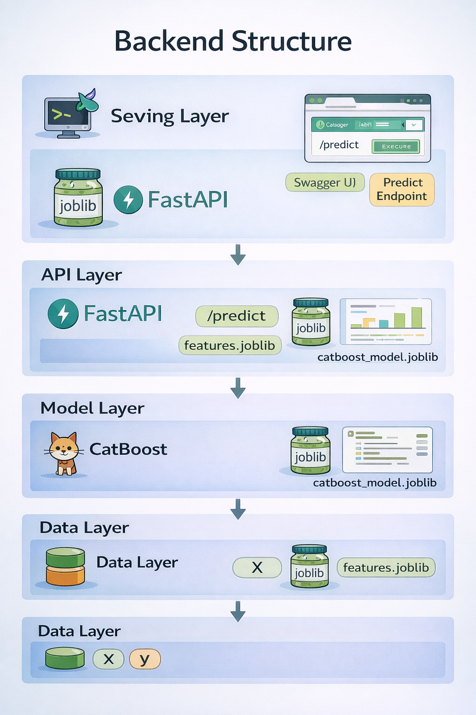

**SUMMARY**: This code builds an injury duration prediction system using a CatBoost classifier. It includes feature engineering (date conversion and one-hot encoding), data splitting, and model training. The trained model is then deployed as a FastAPI backend, enabling real-time predictions via a RESTful API.

**WEEK:5**

# INTRODUCTION: developing the frontend

This project predicts player injury duration using a CatBoost machine learning model. Gradio is used as a frontend to provide an interactive web interface, allowing users to input player data and instantly receive predicted injury durations. The backend handles data preprocessing, feature selection, and prediction using the trained CatBoost model.”

**Step 1 :** This code installs and imports all necessary packages for machine learning and deployment. It includes CatBoost for modeling, Gradio for building the interactive interface, and Scikit-learn for preprocessing, feature selection, and evaluation, ensuring the environment is ready for training and prediction.

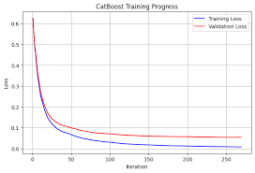

# INSTALL & IMPORT PACKAGES

try:

    from catboost import CatBoostClassifier

except ModuleNotFoundError:

    !pip install -q catboost

    from catboost import CatBoostClassifier

try:

    import gradio as gr

except ModuleNotFoundError:

    !pip install -q gradio joblib openpyxl

    import gradio as gr

import pandas as pd

import numpy as np

import zipfile, os, joblib, warnings

from google.colab import files

from sklearn.model_selection import train_test_split

from sklearn.preprocessing import StandardScaler

from sklearn.pipeline import Pipeline

from sklearn.impute import SimpleImputer

from sklearn.linear_model import LassoCV

from sklearn.ensemble import RandomForestClassifier

from sklearn.metrics import accuracy_score, classification_report

warnings.filterwarnings("ignore")

Summary: This code **installs and imports necessary packages** for machine learning and deployment, including CatBoost for modeling, Gradio for the interface, and Scikit-learn for preprocessing, feature selection, and evaluation. Warnings are suppressed to keep the output clean.

**Step 2:** This code performs **feature engineering and preprocessing** for a machine learning model. Date columns are converted to numeric values, categorical variables are one-hot encoded, and all feature names are saved for consistent use in Gradio.

# FEATURE ENGINEERING

for c in X.columns:

    if "date" in c.lower():

        X[c] = pd.to_datetime(X[c], errors="coerce")

        X[c] = (X[c] - X[c].min()).dt.days

X = pd.get_dummies(X, drop_first=True)

# SAVE ALL FEATURES (IMPORTANT FOR GRADIO)

all_features = X.columns.tolist()

# SPLIT & PREPROCESS

X_train, X_test, y_train, y_test = train_test_split(

    X, y, test_size=0.2, stratify=y, random_state=42

)

prep = Pipeline([

    ("imputer", SimpleImputer(strategy="median")),

    ("scaler", StandardScaler())

])

X_train = pd.DataFrame(prep.fit_transform(X_train), columns=all_features)

X_test  = pd.DataFrame(prep.transform(X_test), columns=all_features)

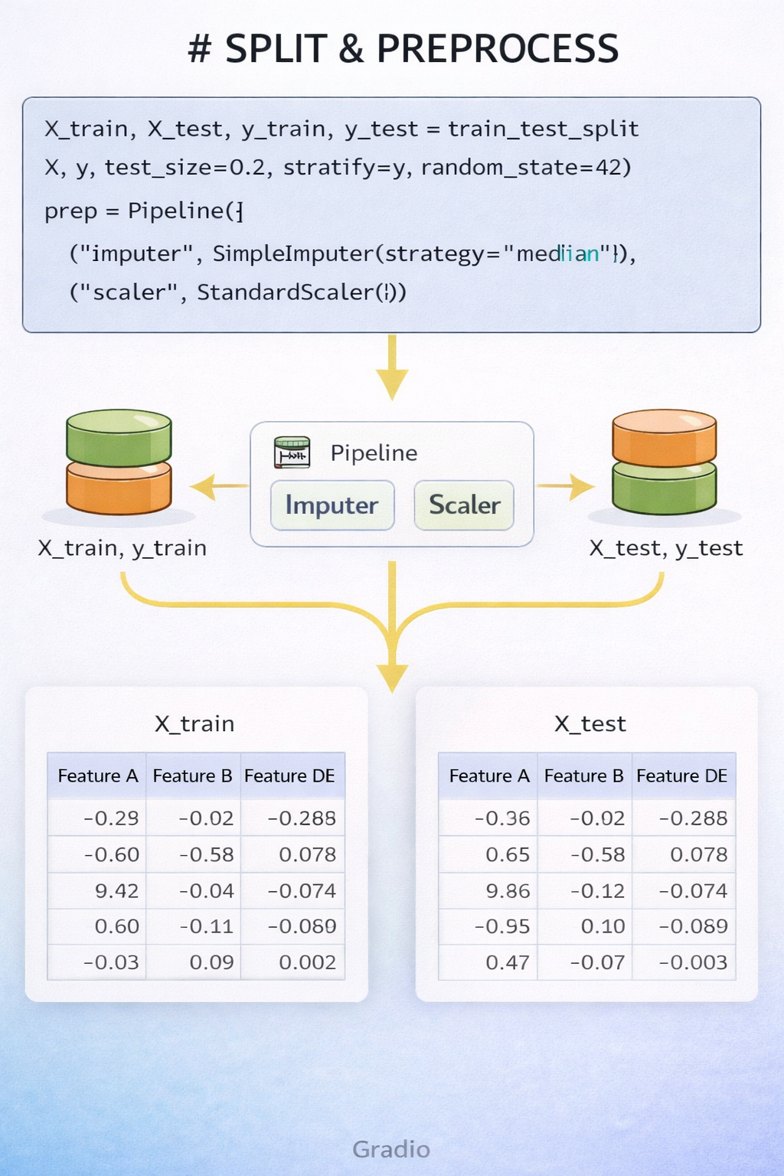

**Summary:** The dataset is split into training and testing sets. Missing values are handled using median imputation, and features are standardized to ensure reliable model training.

**Step 3**: This code performs feature selection to identify the most important predictors for the model. It uses Random Forest to rank feature importance and Lasso regression to further refine the selection.

# FEATURE SELECTION

rf = RandomForestClassifier(n_estimators=300, random_state=42)

rf.fit(X_train, y_train)

rf_imp = pd.Series(rf.feature_importances_, index=all_features)

rf_features = rf_imp[rf_imp > 0.01].index.tolist() or rf_imp.nlargest(5).index.tolist()

X_train = X_train[rf_features]

X_test  = X_test[rf_features]

lasso = LassoCV(cv=5)

lasso.fit(X_train, y_train)

final_features = X_train.columns[np.abs(lasso.coef_) > 0].tolist() or rf_features

X_train = X_train[final_features]

X_test  = X_test[final_features]

print("Final features:", final_features)

**Summary:** Features with low importance are removed, and only the most influential predictors are kept for training. The final selected features are stored for model building.

**Step 4**: This code creates a Gradio web interface for the injury duration prediction model. Users can input feature values, and the interface sends them to the trained model for prediction.

# GRADIO UI

labels = {0: "Short-term Injury", 1: "Medium-term Injury", 2: "Long-term Injury"}

def predict_ui(*inputs):

    # build full feature row

    row = dict.fromkeys(all_features, np.nan)

    row.update(dict(zip(final_features, inputs)))

    df = pd.DataFrame([row])

    # apply preprocessing

    df = pd.DataFrame(prep.transform(df), columns=all_features)

    # select final features

    df = df[final_features]

    pred = model.predict(df)[0]

    return labels[int(pred)]

inputs = [gr.Number(label=f, value=0) for f in final_features]

ui = gr.Interface(

    fn=predict_ui,

    inputs=inputs,

    outputs=gr.Textbox(label="Prediction"),

    title=" Duration Prediction"

)

ui.launch()

**Summary**: This code creates a Gradio web interface for the injury duration prediction model. Users can input feature values, and the interface sends them to the trained model for prediction.

**Final conclusion:** This project uses Artificial Intelligence to predict football player transfer values. It combines player performance data, injury history, market trends, and social media sentiment. By using machine learning and time-series models, the system predicts how a player’s value changes over time. This approach helps clubs and analysts make better transfer decisions.